Experiment 2: Convert an Image to Blur using GaussianBlur
Software / Tools: Python · OpenCV (cv2)

AIM
To read an image and apply Gaussian Blur to smoothen/blur it using OpenCV.
ALGORITHM
1. Import the OpenCV library.
2. Read the input image using cv2.imread().
3. Apply cv2.GaussianBlur() with a chosen odd-sized kernel (e.g. 15x15) and sigmaX = 0.
4. Save and display the original and blurred images.
5. Wait for a key press and close all windows.
PROGRAM (SOURCE CODE)
import cv2

img = cv2.imread("image.jpg")

# Apply Gaussian Blur
blurred_img = cv2.GaussianBlur(img, (15, 15), 0)

cv2.imwrite("blurred_output.jpg", blurred_img)
cv2.imshow("Blurred Image", blurred_img)
cv2.waitKey(0)
cv2.destroyAllWindows()

OUTPUT
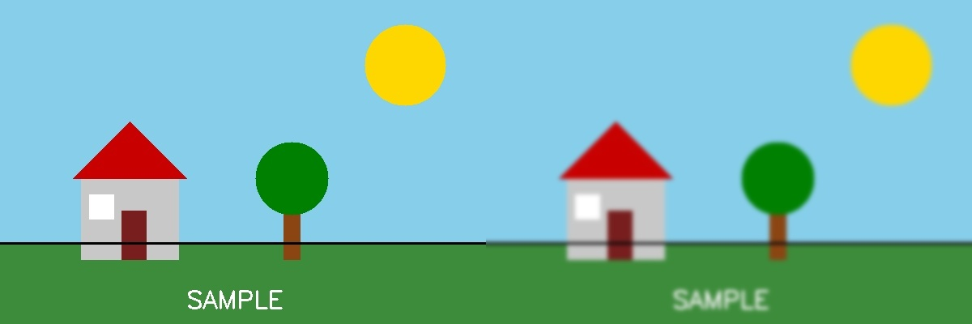
Fig. 2 — Output of Experiment 2: Convert an Image to Blur using GaussianBlur.
RESULT
Read an image and apply Gaussian Blur to smoothen/blur it using OpenCV — completed successfully, as demonstrated in the output shown above.

